PDA week 3 evidence

|  |  |  |  |  |
| --- | --- | --- | --- | --- |
| **Week 3** | **Unit** | **Ref.** | **Evidence** | **Done** |
| I & T | I.T 3 | Demonstrate searching data in a program. Take screenshots of:  *Function that searches data  *The result of the function running |  |
| I & T | I.T 4 | Demonstrate sorting data in a program. Take screenshots of:  *Function that sorts data  *The result of the function running |  |

I.T 3

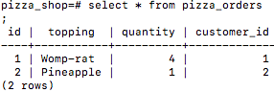

I.T 4

